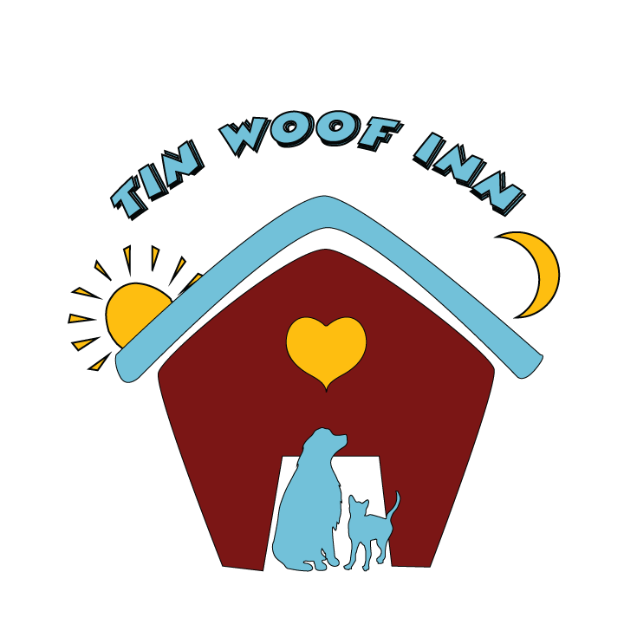**Tin Woof! Inn - Boarding Admission Form**

**1) Client Information**

**Name**: **_____________________________** **Phone: _________________** **Alt Phone: __________________**

**Address: __________________________________ CITY ________________ ST. _____ ZIP__________**

**E-Mail:** **__________________________________________________________**

**Check-In Date**: **____________** **Check-out Date**: **________________ Pick up Time:**  **AM PM**

**2) Pet Information**

**3) Feeding Instructions: Brand ______________________ How much? __________________ How Often? ________________**

**4) Who is your Vet? _________________________________________________________________**

**5) Medications: Name of Med: _________________ Directions for meds: ____________________________________________  
6) Physical Admitting Exam**

|  |  |
| --- | --- |
| **Y N** | **1. Any vomiting, coughing, sneezing, or diarrhea? If Yes, please list ___________________________________** |
| **Y N** | **2. Has your pet had any illness or injury in the past 30 days? If Yes, please list ___________________________** |
| **Y N**  **Y N** | **3. Does your pet have any skin issues? (Hot spots, etc.) _______________________________________________**  **4. Does your pet have any allergies? If yes, please explain _____________________________________________** |

**7) Required Vaccinations: We require all pets to be current on: Rabies, D/H/P/P, Bordetella**

**____ Copy given to TWI ______ Please call my vet for an update _____ Previously on record**

**8) How did you hear about Tin Woof! Inn?**

____**Website/Facebook ______Newspaper/Radio/Commercial ______Friend/Family~Name: _________________________**

**If ticks or fleas are detected, appropriate treatment will be given for a fee.**

**9) Owner’s release: As the pet’s owner, I understand:**

**A) TWI cannot guarantee the health of my pet. B) All pets admitted to TWI or under TWI care must be protected against communicable diseases and must be free of internal and external parasites or will be treated on entry or discovery at the owner/agent’s expense. C) TWI is not responsible for loss or damage to personal items left with pet including but not limited to: leashes, collars, toys, blankets and bedding. D) If I do not pick up my pet within 7 days of the date scheduled for discharge, or make other arrangements by phone or email, the facility will assume that the pet is abandoned & is hereby authorized to adopt out or take the pet to the local shelter. E) Any minor problems that develop with my pet will be noted and I assume full responsibility for the treatment. F) If any medical problem is observed or develops TWI will use professional judgment, place the pet’s health first, and have the pet treated by my vet or theirs if necessary. TWI will try to contact me, but I understand that if they cannot get in contact with me, they will do what is best for my pet. This form and my signature authorize a veterinarian to treat my pet. G) This release applies to this and any future stays unless mutually modified. H) If my pet bites another dog, person or employee, I may be liable for medical expenses. Depending on the situation, TWI may be required to report a bite incident to local Animal Control and the County Health Department. I) I give permission for TWI to use my dog in photos and videos on any social media and advertising. J) By signing this form, I am giving written authorization for TWI to access any and all veterinary records. K) I give TWI permission to remove any and all collars, harnesses, etc. from my pet. L) I will not dispute payment to TWI for any reason, this waiver serves as agreement to any and all charges. M) Failure to pay TWI in full for services will result in legal action taken against me. I agree to be taken to court in Boyd/Rowan/Franklin County for any matters.**

**Tin Woof Inn (and staff) will: I) Use all reasonable precaution against injury, escape, or death to my pet. II) Not be held liable for any problems that develop provided reasonable care and precautions are followed.**

**Owner’s Signature____________________________________________________ Date: __________________**

**In Case of Emergency please call ________________________ at the following number______________________________**

**TWI CheckIn v 14.0 1-10-2022**

**Please Choose**:  **GROOM: Yes No BATH: Yes No NAILS: Yes No**

**TWI CheckIn v 6.0 3-3-14**